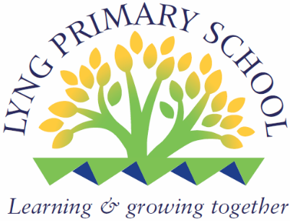

Lyng Primary School
Job Description for Teacher
Name:
Post Title: | Teacher
Pay Scale | TMS
Effective commencement date: | Summer 2026

The postholder is immediately responsible to: Headteacher
1. (a) General Professional Duties and Responsibilities

The postholder is required to carry out under the reasonable direction of the Head Teacher (or Head of Service) the professional duties of a teacher which are set out in the relevant paragraphs of the School Teachers Pay and Conditions Document and any subsequent amendments.

- The postholder must at all times carry out her/his responsibilities with due regard to the Council's Equal Opportunities Policy.

- Particular Responsibilities (These do not include or imply any voluntary activities.)

Note

- This job description is not necessarily a comprehensive definition of the post.

- The particular duties and responsibilities listed above may be subject to reasonable change from time to time following consultation between the Head Teacher with the postholder.

Issued by: (Headtecher)

Date of Issue:

Received by: (Postholder)

Date received:

One copy of the Job Description should be retained by the Head Teacher/Head of Service, one copy given to the postholder and one copy sent to Employee Services

